The Green Schools Committee
Sandford Park School is a proud member of the world wide Green Schools Project. The aim of this global project is to encourage schools to actively reduce their harmful or negative effects on the environment.

The Green Schools Committee of Sandford Park School is a committee made up of students, teachers and parents. The main goal of the green school’s committee is to achieve the Green Flags. The flags are not just awards for being a clean school but demonstrate that schools are contributing in a positive way to the saving of the environment and reducing polluting effects. So far Sandford Park has obtained five green flags: Biodiversity, Energy, Water, Travel, Litter and Waste. The school is making progress towards obtaining the next green flag which is for Global Citizenship – Litter & Waste.

Students are staff are going to be undertaking initiatives over the course of the next two years focusing on raising awareness on previous themes. Students are writing articles on various issues to be displayed on the school website, in The Griffin and as part of the Young Reporters for the Environment competition ran by An Taisce. Green School initiatives also involved cross-curricular work with many different subjects within the school such as:
Form II Science – Three students are completing a project on raising awareness on future climate change. The project was investigating "A comparison of the effects of acidification on blue mussels (saltwater) and pearl mussels (freshwater) by the 22nd century”. This will be entered in SciFest this year taking place in IT Tallaght.
Form I Art and English – Raising an awareness and trying to secure a reduction on the amount of single use plastic in our homes. 1SOL created headdresses from single use plastics in their Art class with Ms Doran. These will then be displayed over the course of the year. An article was then written on the event by student’s in their English lesson.
Form TY Geography – Students are working on using the school Biodome to grow produce that can be used in the school canteen. They are also going to try and come up with their own ideas for soups that they can produce using vegetables they have grown over the course of the year such as spinach and tomatoes.

Green Schools Fifth Flag – Success in Biodiversity!
The Green Schools committee is delighted to have secured the school’s fifth Green Flag for Biodiversity. The Green Schools committee worked extremely hard in the weeks coming up to and throughout Biodiversity Week. Each member of the committee was assigned tasks, and endeavoured to complete these tasks to the best of their abilities.
We took a five prong approach towards spreading awareness of Biodiversity in the school.
- Informing Students and Staff
- Posters and signs were displayed around the school.
- Informative pieces in all tutor folders.
- Informative postcards were placed on tables in the canteen and staffroom.
- National Sustainability Summit – Four students were brought by Ms. Duggan.
- Cross-curricular
- Teachers were asked to link biodiversity to any areas of their own subject.
- Biodiversity Assembly
- An assembly was held in the canteen for Form I to III.
- William Despard of The Bretzel Bakery was a guest speaker and spoke about running a sustainable company. He brought in his green car, electric trike, and samples of the bread for staff and students to try.
- Biodiversity Survey
- The original biodiversity survey completed before biodiversity week was handed out again to all forms during an extended registration, the week after Biodiversity Week. This data was compiled by Form II students during maths class, and the results can be seen on the Green Schools noticeboard outside the library. The results show a marked increase in understanding and knowledge of Biodiversity from the first survey.
- Planting of flowers/insect hotel
- Members of the committee were involved in planting bulbs/pots to create new Biodiversity in the school.
- An insect hotel was also installed near the flower bed at the front of the school to give a home for insects and increase the diversity in that area
Overall, the members of the Green Schools committee feel that securing a fifth flag last year was a great success. We will continue to raise awareness and inform our fellow students at Sandford Park School about environmental issues such as Biodiversity, Energy, Water, Travel, Litter and Waste.

Sustainable Development Goals
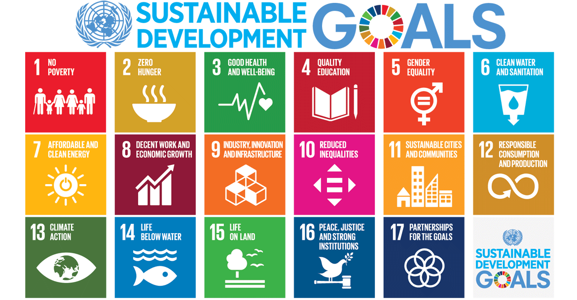
Sandford Park School has taken a very hand on approach to sustainability in the academic year 2018/2019. We have implemented sustainability education into our first year CSPE curriculum, we have been working hard on achieving our 6th Green flag, after our success last year in achieving flag number 5, and we also have two students going to Brussels during European Youth Week to give workshops to the delegates on the Sustainable Development Goals (SDG’s).
Our first years have been working hard learning all about sustainability and what they can do to help. They’ve taken part in workshops with the artist Annie Holland and created incredible headdresses out of recycled material. They were also given workshops by two fifth-year students Jack Brocklebank and Martha Carey, during the workshop they became much more familiar with the SDG’s and came up with ideas for actions projects which they could undertake next year. They really enjoyed the process and their knowledge of the SDG’s has been maintained by frequent class discussion, they were also very active in regard to the recent student strike against climate change held on the 15th of March in Dublin city centre and many students turned out even though they had the day off from school.
Martha and I will also be travelling to Brussels during European Youth Week to represent ECO-UNESCO. We will give talks, run workshops and we have also developed a game to play as a more hands on approach to learning about the goals. On our return we will brief the first years and the teachers in the CSPE department on what we learnt while away and we hope to bring that information to the school to help and improve the measures we have already put in place and maybe even implement more.
  - Jack Brocklebank (TY KMcB)

Thank you Sandford Park School, from Dublin City Council
Dublin City Council contacted the school to thank us for our Walkability Audit completed in December 2014. Although, it was completed a few year ago, it has been used as by Dublin City Council as a reason to install a pedestrian crossing at the bottom of Malborough Road. This shows us that our actions we take as a Committee goes further than just the front gates of Sandford Park School. Well done to everybody involved!
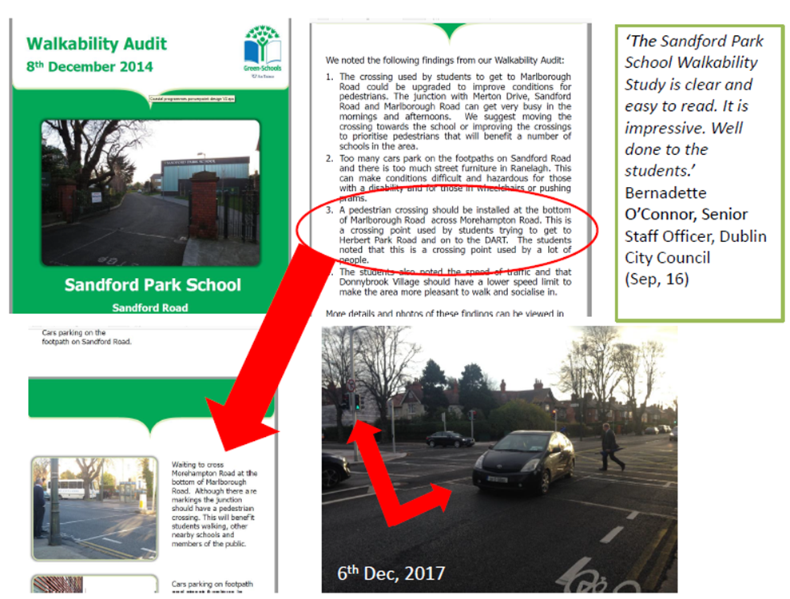

PLASTIC HEADDRESS PROJECT

In CSPE and Visual Art this year, we have focused a lot on being environment friendly. With our teacher, Ms. Doran, we have learnt about how plastic is affecting our planet, i.e. killing fish and sea creatures and birds. We wanted to use plastic as an art material to create a piece of sculpture or art. Ms. Doran had the idea to make 3D sculpture pieces using plastic that can’t be recycled.

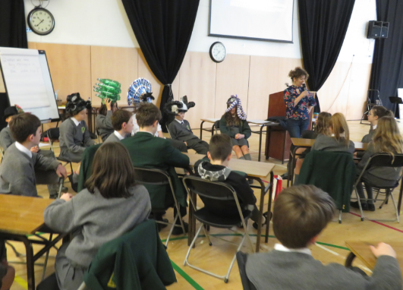
We invited the artist and photographer Annie Holland to come in to do some workshops with all of Form 1 as she creates plastic headdresses of her own. We spent a week tracking our plastic use and collecting as much plastic as possible at home. Then, we brought it all in to Visual Art class. On Friday, all of Form 1 gathered in the hall. Annie Holland talked to us about plastic and recycling. She also showed us some video clips and some of her artwork. We discussed how we can reduce, reuse and recycle or eliminate plastic use.
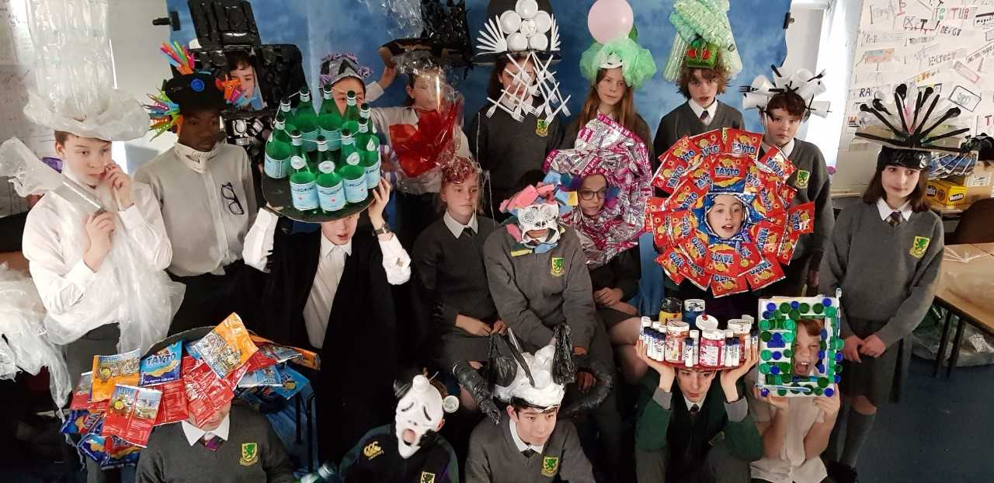
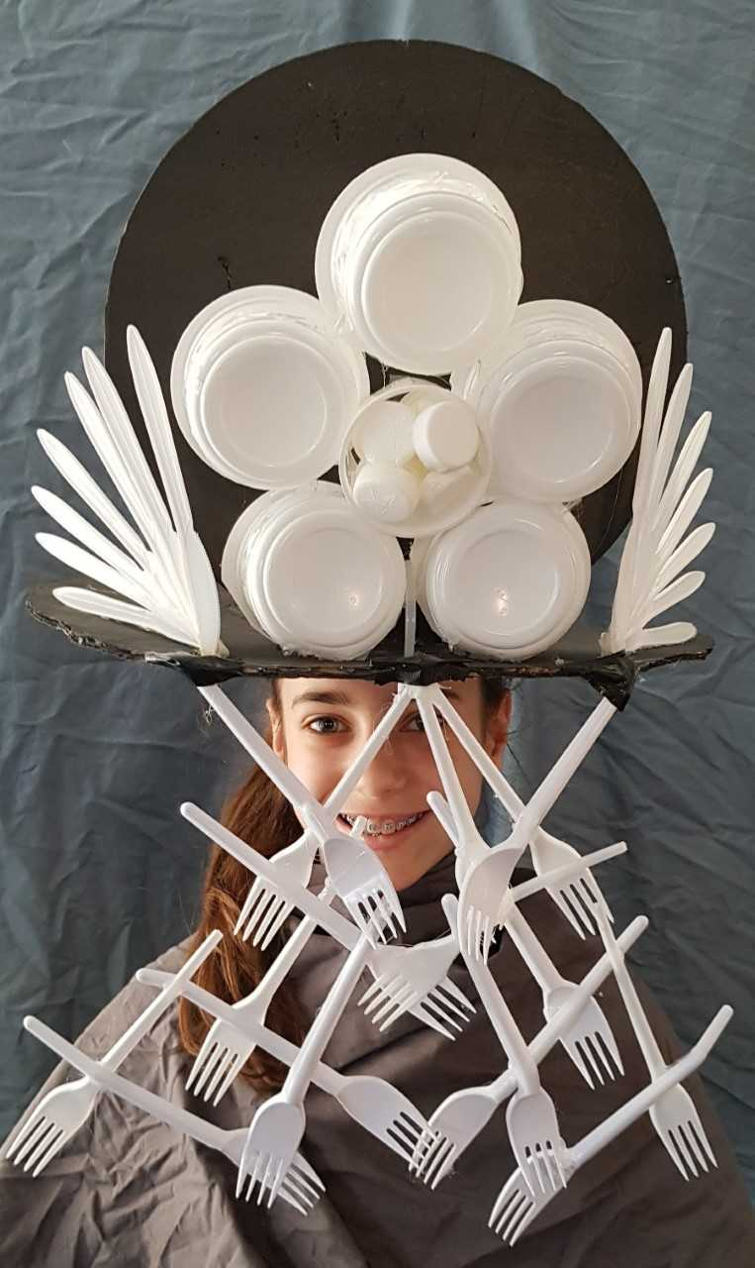
Then Form 1 SOL did some art workshops with Annie Holland. We got into small groups or pairs to work with plastic. My partner was Aurora. We decided that the theme for our headdress would be forks and cups. Everyone used plenty of plastic and hot glue to put everything together. Once the headdresses were finished, Annie Holland photographed us wearing our final pieces! I found the entire experience very enjoyable and I hope that we can continue to raise awareness about environmental challenges through our art.

Charlotte Turner
1SOL
Sandford Park School

